•

- Sulakhan Singh Gill, Amrit Gill, AnoopInder Singh Chahal and 36 others like this.
- View all 20 comments
- 
Gagandeep Grewal es de parle paase, sabh ton purani chicken di dukaan hundi si.. " Lajawaab"..chawla ton vi purani..may be late 80,s ton.
3 hours ago via mobile · Like
- 

Options
• 

Gurmehar Singh

On this day (August 29, 2010) MS Saini addressed first year students (2010-2014 batch) and said "EVERY STUDENT SHOULD WALK ON FOOT-STEPS OF GURMEHAR."
As a respect to the chair of Director, if even 10 students of that batch copy my way, he will be out in a week :) — with Amit Chaudhary and Prabhjot Singh Cheema.
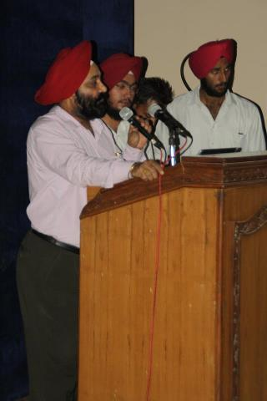

Like · · Follow Post · 17 hours ago

- Jaspreet Singh Dhillon, Rimaljit Kaur, Kaviraj Bajwa and 28 others like this.
- View all 5 comments
Gagandeep Grewal Yaar, es kutte-kutt jahe naal photo zroor launi si ethay.
4 hours ago via mobile · Like
- 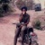
Darshan Dhillon Yar in lighter way "photo vich ta menu tene he pagwat bhara lagde ne"

